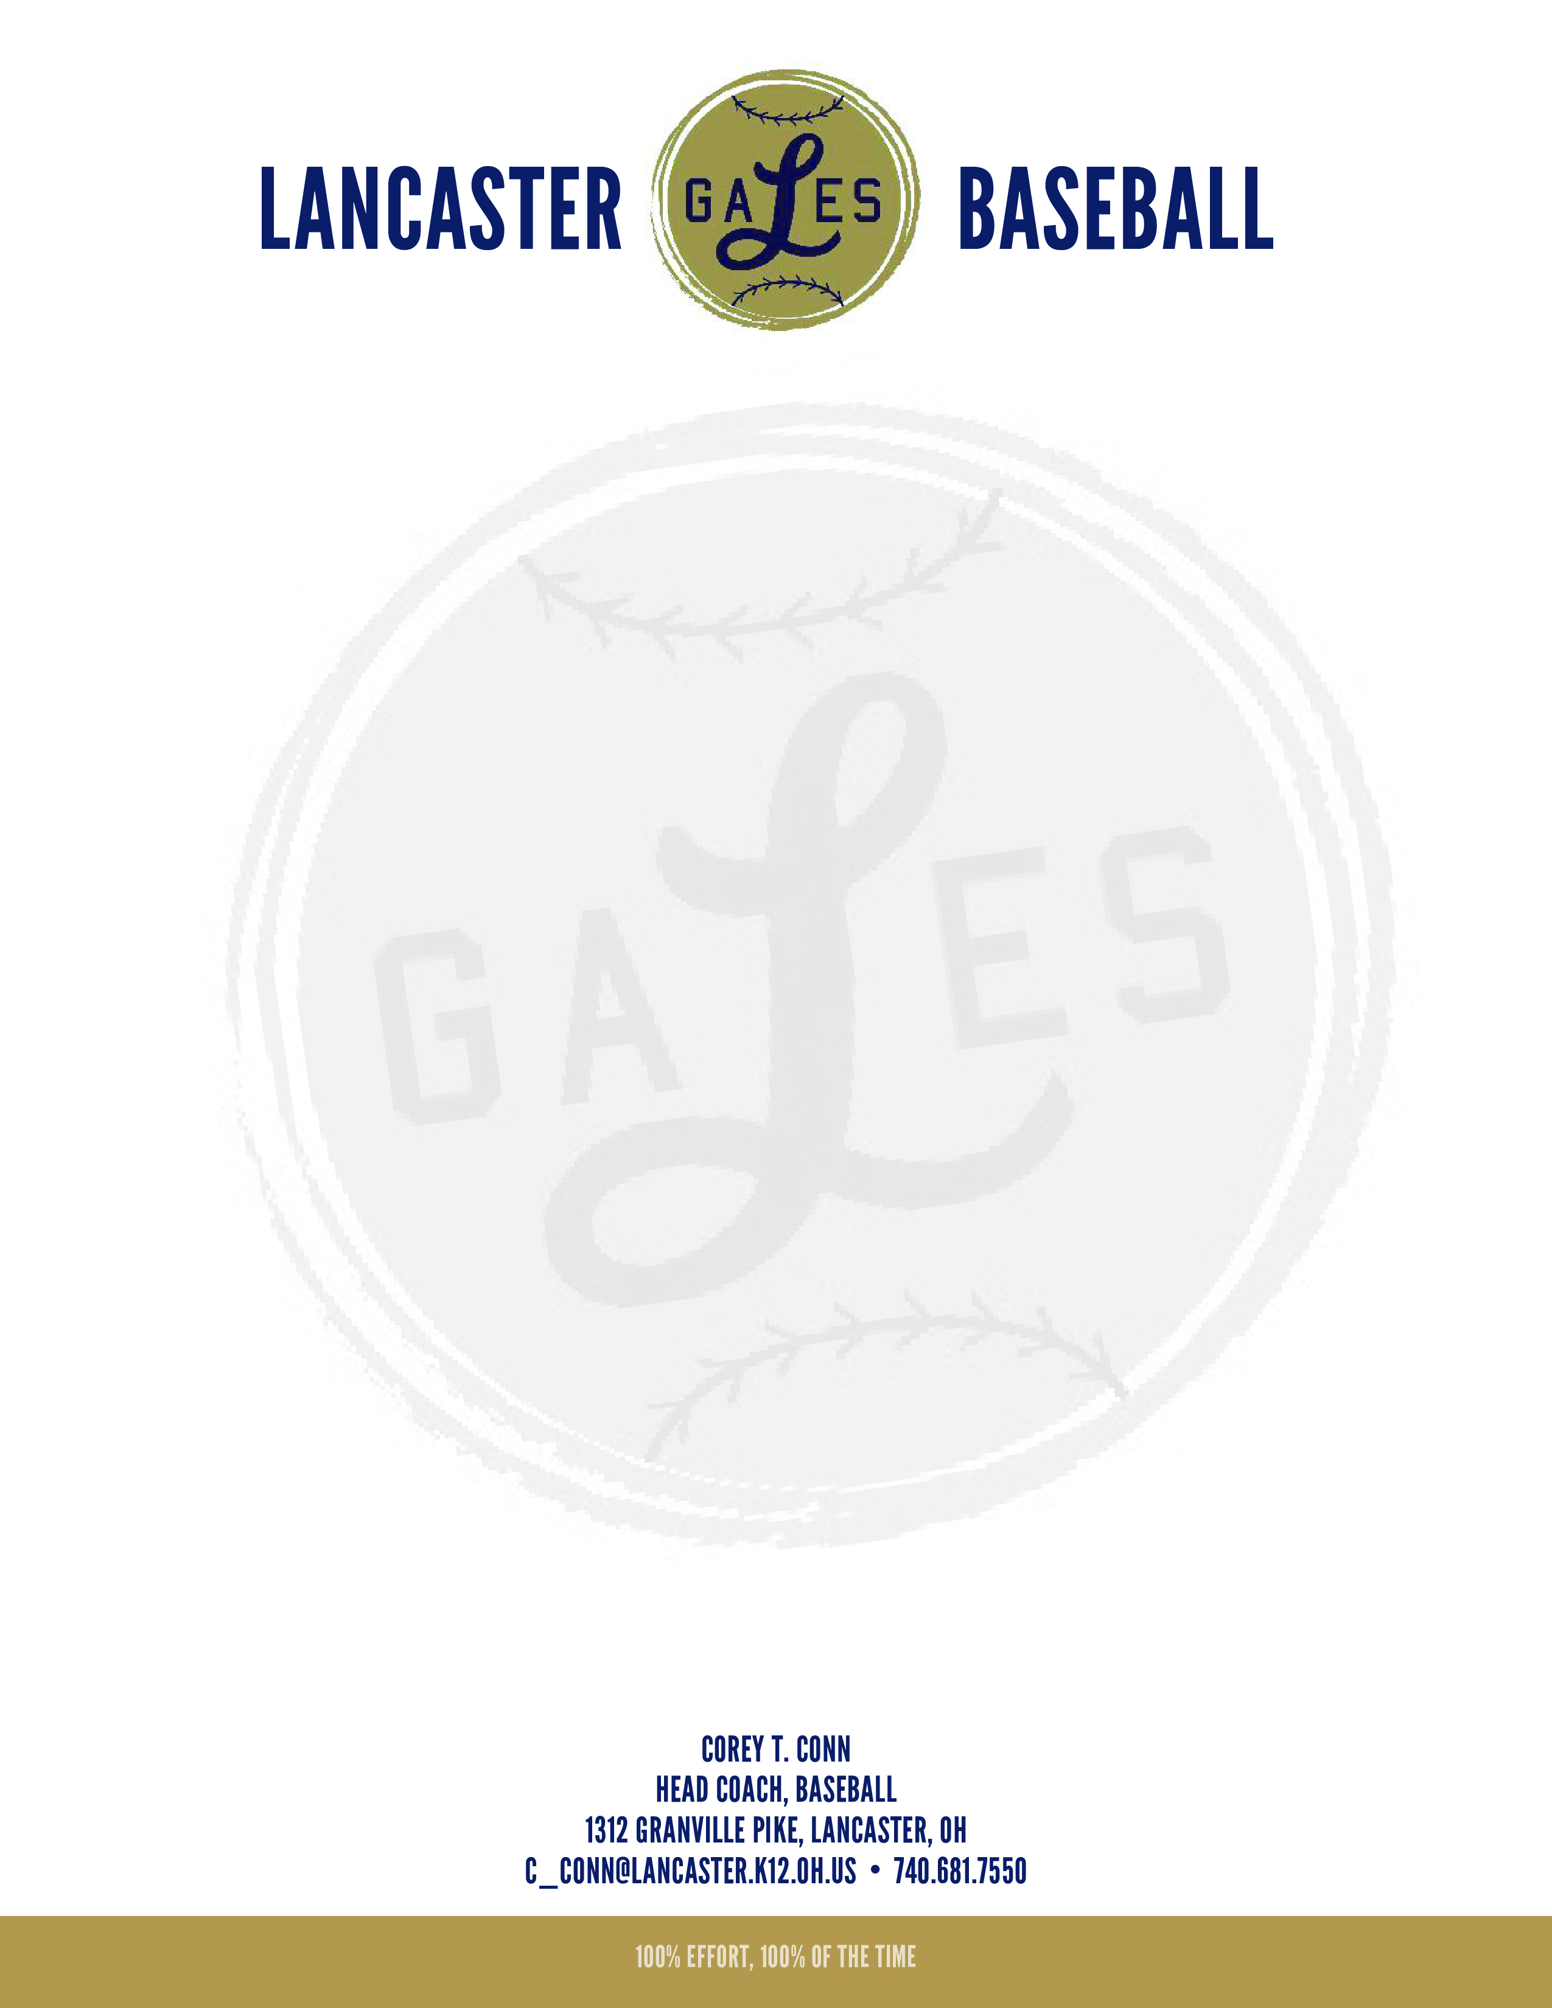

Harrison Gilmore

**Height**: 6’5’’

**Weight**: 250

**Year**: Junior, 2016

**Position**: RHP/1B

**In free time enjoys**: Disc Golfing, hiking, Tap sports baseball, watching the Reds

**Favorite Food**: Italian Food

**Favorite Music**: Logic, A$AP Rocky, Toby Keith, Frank Sinatra

**Nickname**: Harry the Impaler

**Favorite Quote**: “*You’re my boy blue!”*

**Twitter**: @Gillzworld